Project Planning Phase
Project Planning Template (Product Backlog, Sprint Planning, Stories, Story points)

Date | 15 February 2025
Team ID
Project Name | Team Enrollment Confirmation - Import Data using Transform Maps (Spreadsheet)
Team Size | 4
Team Leader | SRIKAVI T
Team Members | ISWARYA S, YOGASRI S, KEERTHIKA L
Maximum Marks | 5 Marks

Product Backlog, Sprint Schedule, and Estimation (4 Marks)
Use the below template to create product backlog and sprint schedule
Sprint | Functional Requirement (Epic) | User Story Number | User Story / Task | Story Points | Priority | Team Members
Sprint-1 | Data Source Setup | USN-1 | As a team leader, I can prepare the enrollment spreadsheet (Excel) with team member name, email, role and enrollment status columns. | 3 | High | Srikavi T
Sprint-1 | Data Source Setup | USN-2 | As an admin, I can create the Team Enrollment custom table with all required fields to store the imported data. | 5 | High | Iswarya S
Sprint-1 | Data Source Setup | USN-3 | As an admin, I can configure user roles and access controls (ACL) for the Team Enrollment table. | 3 | Medium | Yogasri S
Sprint-1 | Data Source Setup | USN-4 | As an admin, I can load the spreadsheet as a data source and create the Import Set table. | 5 | High | Keerthika L
Sprint-1 | Data Source Setup | USN-5 | As a team member, I can validate the file format, column headers and sample data before import. | 4 | High | Srikavi T
Sprint-2 | Transform Map Configuration | USN-6 | As an admin, I can create a Transform Map from the Import Set table to the Team Enrollment table. | 5 | High | Iswarya S
Sprint-2 | Transform Map Configuration | USN-7 | As an admin, I can map source fields to target fields so each spreadsheet column lands in the correct field. | 4 | High | Yogasri S
Sprint-2 | Transform Map Configuration | USN-8 | As an admin, I can coalesce on the email field so duplicate enrollment records are not created. | 3 | High | Keerthika L
Sprint-2 | Transform Map Configuration | USN-9 | As an admin, I can add a transform script to clean data (trim spaces, standardize case) during import. | 4 | Medium | Srikavi T
Sprint-2 | Transform Map Configuration | USN-10 | As an admin, I can run the transform and verify that records are imported into the target table. | 4 | High | Iswarya S
Sprint-3 | Enrollment Confirmation | USN-11 | As an admin, I can add an Enrollment Status field with choices Pending, Confirmed and Rejected. | 3 | High | Yogasri S
Sprint-3 | Enrollment Confirmation | USN-12 | As an admin, I can create a business rule that sets status to Confirmed when all required details are present. | 5 | High | Keerthika L
Sprint-3 | Enrollment Confirmation | USN-13 | As a team member, I will receive a confirmation email once my enrollment is confirmed. | 5 | High | Srikavi T
Sprint-3 | Enrollment Confirmation | USN-14 | As a team leader, I can view a list and report of confirmed enrollments. | 4 | Medium | Iswarya S
Sprint-3 | Enrollment Confirmation | USN-15 | As an admin, I can review import logs and skipped or ignored rows to correct errors. | 3 | Medium | Yogasri S
Sprint-4 | Testing & Deployment | USN-16 | As a tester, I can import a valid dataset and confirm all records are transformed correctly. | 4 | High | Keerthika L
Sprint-4 | Testing & Deployment | USN-17 | As a tester, I can import invalid and duplicate data and confirm it is handled properly. | 4 | High | Yogasri S
Sprint-4 | Testing & Deployment | USN-18 | As a team, we can perform user acceptance testing and fix reported defects. | 5 | High | Iswarya S
Sprint-4 | Testing & Deployment | USN-19 | As a team leader, I can prepare the project documentation and final demo. | 4 | Medium | Srikavi T
Sprint-4 | Testing & Deployment | USN-20 | As an admin, I can move the completed configuration to the final instance using an update set. | 3 | Medium | Keerthika L

Project Tracker, Velocity & Burndown Chart: (4 Marks)
Sprint | Total Story Points | Duration | Sprint Start Date | Sprint End Date (Planned) | Story Points Completed (as on Planned End Date) | Sprint Release Date (Actual)
Sprint-1 | 20 | 6 Days | 24 Oct 2022 | 29 Oct 2022 | 20 | 29 Oct 2022
Sprint-2 | 20 | 6 Days | 31 Oct 2022 | 05 Nov 2022
Sprint-3 | 20 | 6 Days | 07 Nov 2022 | 12 Nov 2022
Sprint-4 | 20 | 6 Days | 14 Nov 2022 | 19 Nov 2022

Velocity:
Imagine we have a 10-day sprint duration, and the velocity of the team is 20 (points per sprint). Let’s calculate the team’s average velocity (AV) per iteration unit (story points per day)


For this project: each sprint is 6 days with a velocity of 20 story points, so the average velocity (AV) = velocity / sprint duration = 20 / 6 = 3.33 story points per day (80 story points over 4 sprints and 24 days). Note: the 10-day example above uses the same idea: 20 / 10 = 2 story points per day.
Burndown Chart:
A burn down chart is a graphical representation of work left to do versus time. It is often used in agile software development methodologies such as Scrum. However, burn down charts can be applied to any project containing measurable progress over time.
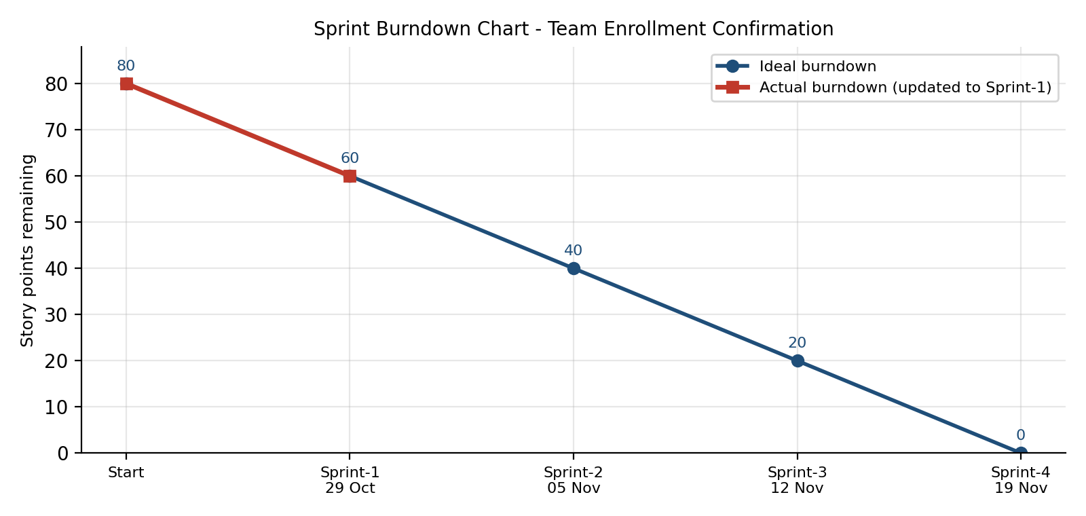
https://www.visual-paradigm.com/scrum/scrum-burndown-chart/
https://www.atlassian.com/agile/tutorials/burndown-charts

Reference:
https://www.atlassian.com/agile/project-management
https://www.atlassian.com/agile/tutorials/how-to-do-scrum-with-jira-software
https://www.atlassian.com/agile/tutorials/epics
https://www.atlassian.com/agile/tutorials/sprints
https://www.atlassian.com/agile/project-management/estimation
https://www.atlassian.com/agile/tutorials/burndown-charts

